Artificial Intelligence and Cybersecurity : Balancing Risks and Rewards
WHITE PAPER
JANUARY 2025
Lead authors
Louise Axon, Research Fellow, Global Cyber Security Capacity Centre, University of Oxford
Joanna Bouckaert, Community Lead, Centre for Cybersecurity, World Economic Forum
Sadie Creese, Professor, Cybersecurity, University of Oxford
Akshay Joshi, Head, Centre for Cybersecurity, World Economic Forum
Jamie Saunders, Oxford Martin Fellow, University of Oxford

Throughout the report, we explore a central question:
How can organizations reap the benefits of AI adoption while mitigating the associated cybersecurity risks?
Sadie Creese

- The business benefits of adopting AI can be considerable, but the cyber risks of embedding these technologies into an organization are not always considered from the outset. By adopting AI, businesses may find themselves vulnerable to new threats that they do not yet know how to defend themselves against.
- The impact of AI on cybersecurity can be considered to fall into three broad categories:
- The use of AI by threat actors: Threat actors are using AI to enhance their capabilities and make their tactics, techniques and procedures more potent, and attacks more effective.
- The use of AI by defenders: In parallel, cyber defenders are harnessing AI to enhance cybersecurity capabilities, facilitating wider prevention, more accurate threat detection, autonomous remediation and more rapid and effective incident response.
- Cybersecurity for AI: The use of AI is creating an expanded attack surface that might be exploited by threat actors. Existing methods need to be extended to address new vulnerabilities that are inherent in AI, but that may not be as relevant for “classical” IT systems.
- Reconnaissance: AI has enhanced reconnaissance efforts for cybercriminals by automating and refining the information gathering process. Attackers can efficiently analyse vast amounts of data from various sources, such as by scraping social media, public records and network traffic to identify potential targets and vulnerabilities. Though not a novel use case, AI tools can process and correlate this data with greater speed and accuracy, making target selection and external surface scanning more efficient and effective.3 For example, AI can detect and map out organizational structures, pinpoint weaknesses in security configurations and predict likely security behaviours and responses.
- Discovering and exploiting zero-days: AI allows cybercriminals to accelerate the process of discovering unpatched vulnerabilities such as zero-days – unknown vulnerabilities that do not have any patch or fix available – more efficiently and at scale. AI-enabled reconnaissance tools not only streamline the identification of zero-day vulnerabilities but also make it easier to create custom malware capable of exploiting these weaknesses before patches can be deployed. Researchers have also found that multiple GPT-4 models working in tandem are capable of autonomously exploiting zero-day vulnerabilities.
- Compromising AI systems: This involves cybercriminals exploiting weaknesses in AI training datasets via data poisoning attacks,5 model architectures and operational frameworks. Data poisoning can degrade a model’s performance and reliability, leading to erroneous outputs6 with far-reaching, sector-specific consequences. In the financial sector, for example, a successful data poisoning attack could manipulate algorithms used for credit scoring or fraud detection. Such outcomes not only undermine the integrity of systems, but also expose institutions to significant financial losses and reputational damage
- Level of AI autonomy: Where autonomous AI drives business processes without human oversight, this may create greater risk. Lower risk is faced when there is little autonomy or strong human oversight to limit risk propagation.

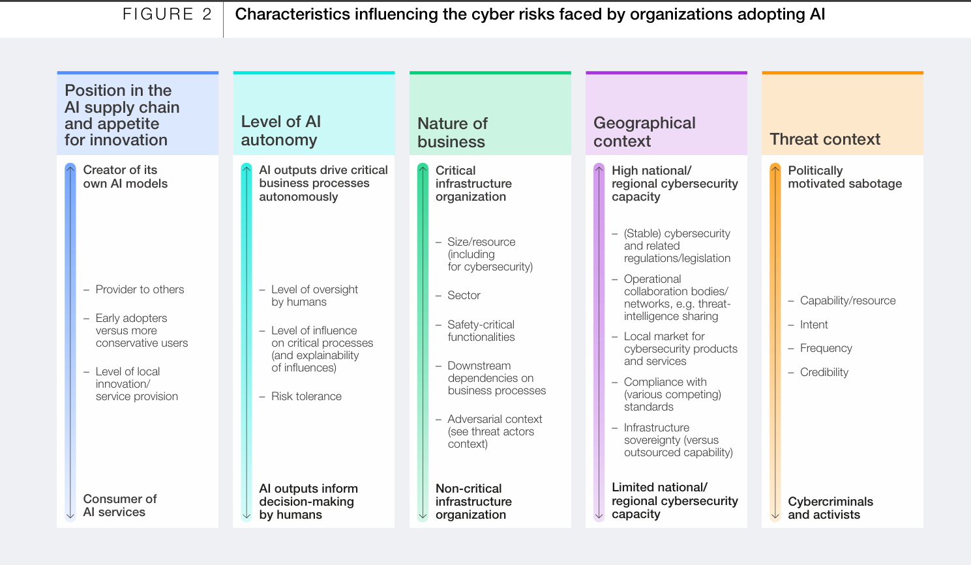

- Existing controls
